**Spanish 11 - Culture Project #1 (5%)**  
  
**Learning outcome addressed:**

* Compare, contrast, and respond to authentic creative works from the Hispanic world;
* Retrieve, research, and use relevant information from Spanish-language resources to complete meaningful tasks;
* Summarize acquired information in visual and written forms.

Research **two of the topics below** (or of your choosing) related to authentic creative works that have originated from the Spanish speaking culture. (There are 20 different countries where Spanish is one of the official languages)  
  
Use the guideline below as a **framework** for your research:

* Name the creative works.
* Who are the artists?
* When was this piece created?
* For whom was this piece created?
* Where was this piece created?
* Why was this piece created?
* What message is this piece communicating?
* Do other works by the same artist reflect similar things?
* **Compare and contrast the work of two different artists/art types you have chosen.**
* **What is your reflection on this piece of work?  What is revealed about the culture in the work? How do they compare to each other. (This is important)**

**Experiencing Creative Works:**

|  |  |
| --- | --- |
| SAMPLE TOPIC AREAS | The artistic creative work of the following: |
| Art/Artists – the work of: | Francisco de Goya, Diego Velazquez, Joan Miro, Pablo Picasso, Salvador Dali, El Greco, Diego Rivera, Frida Kahlo, |
| The music of: | Ricky Martin, Celia Cruz, Marc Anthony, Christina Aguilera, Carlos Santana, Gloria Estefán |
| Dance/Theatre | Tango, Bolero, Flameco, Doble Paso, Salsa, Samba, Merengue, Mambo, Cha Cha, Cumbia, Rumba |
| Architectural work of: | Antoní Gaudi |
| Film/Actors – the work of: | Penelope Cruz, Andy García, Desí Arnaz, America Ferrera, Raúl Julia, Rita Moreno, Jimmy Smits, Sofía Vergara |
| Literature/Poetry of: | Pablo Neruda, Isabél Allende, Miguel de Cervantes, Gabriel García Márquez, Carlos Ruíz Zafrón, Federico García Lorca, Octavio Paz, Francisco Ayala |

**Step 1:**  
Find 5- 7 resources **in Spanish** (i.e. internet, books, pictures, newspaper articles, magazine, e-zine, music) you will use to complete this project. Cite your resources in a bibliography.

Note: How can you find Spanish language resources? Try this tip. Go to Google and click on the Advance Search link. Next to Search within a site or domain, type in the country code for a Spanish country. (click here for all country codes: <http://www.theodora.com/country_digraphs.html> ). As well, be sure to use Spanish keywords, i.e. arte de Goya, obras de Goya, etc. For example, for Spain, type in the extension .es; for Mexico, type in the extension .mx.

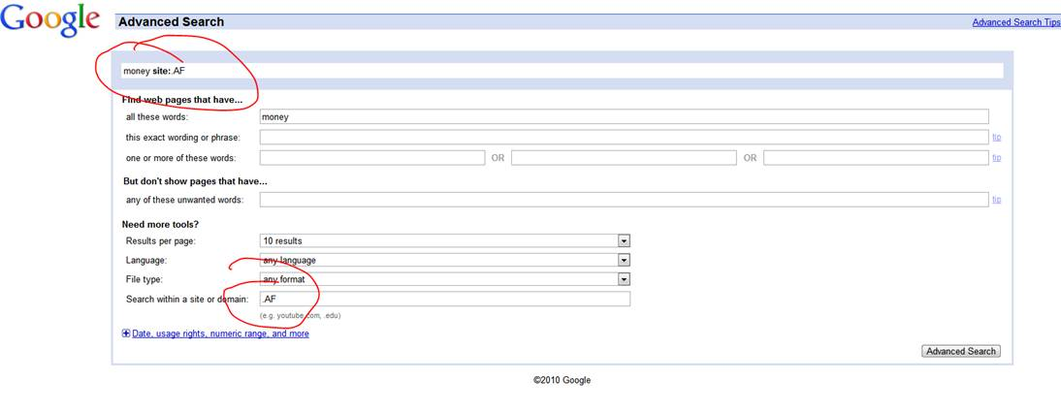  
**Step 2:**  
Using your resources, put together a written project **in Spanish** with visual or auditory support (refer to our class website for links on how to type in accents in Spanish). The use of multimedia is encouraged (i.e. Powerpoint, Wiki, Glogster, Google Doc, Podcast, Videocast, Screencast, etc). Please let your teacher know if you need some assistance in this area.  
  
**Note:** Copying and pasting complete or partial sentences from other sources, without citing the author, is considered a copyright infringement. Please refer to our policy on [Academic Integrity](http://www.sd43.bc.ca/col/10-12/About/Policies/Policy%20Documents/Academic%20Integrity%20Policy.pdf). Images from the Internet can be used if you cite the link and/or owner of the image. Please ask for help if you are unsure.   
  
**Step 3:**  
Post your work to the class site or wiki (location to be announced) for other students to view and respond to (or send to the teacher to be posted).

**Assessment (24 marks)**

Exceeds                Meets                   Barely Meets          Doesn’t meet

|  |  |  |  |  |
| --- | --- | --- | --- | --- |
| Identifies work as being associated with culture - features/ context, indicates significance of the work.  Compares/Contrasts  **/8** | Very clearly identifies and describes the significance or connection of the work to the culture and the student. | Clearly identifies and describes the significance or connection of the work to the culture and the student. | Attempts to identify and describe the significance or connection of the work to the culture and to the student. | Neglects to identify and describe the significance or connection of the work to the culture and the student. |
| Compare/contrast the two artists/works of art  Compare (how are they alike)  Contrast (how are they different)  **/4** | Points to specific examples to illustrate the comparison. Includes both comparison and contrast. | Compares and contrasts items but the supporting details are general and not specific. Includes both comparison and contrast. | Compares and contrasts items but the supporting details are incomplete. Includes both comparison and contrast. | Paper compares or contrasts but does not do both. There is no supporting details or support is incomplete. |
| Variety/ quality of resources and media  **/4** | A wide variety of resources is used in researching and producing the assignment - a wide diversity of perspectives is derived from them | A variety of resources is used in researching and producing the assignment - some diversity of perspectives is derived from them | Limited variety of resources is used in researching and producing the assignment - not much perspective is derived from them | Inadequate variety of resources is used in researching and producing the assignment - diversity of perspectives is not derived from them |
| Clarity of understanding **/4** | Information is clear, relevant, accurate, and detailed. | Information is clear, relevant, and accurate. | Information is relevant and accurate, but may be unclear or inaccurate in places. | Attempts to address the topic. but Information of the message  may be unclear, incomplete, or inappropriate. May deal with requirements in a cursory way or show  inconsistency. |
| Project Presentation  **/4** | Information is well-organized, and easy to understand.   The illustration(s) or photo(s) or sounds  is interesting, relevant, attractive, and supports the ideas described. | Information is displayed well.   The illustration(s) or photo(s) supports the ideas described. | Information may seem to  be displayed without purpose or relevance.   The illustration(s) or photo(s) is somewhat related to text and/or there is limited visual or auditory impact. | Some irrelevant information is included.  Illustrations or photos may be missing or unrelated to text. |