**Spanish 11 - Culture Project #2 (5%)**  
  
**Learning outcome addressed:**

* Demonstrate an understanding of similarities and differences between Hispanic cultures;
* Identify and compare language, expressions, and behaviours that reflect cultural context;
* Retrieve, research, and use relevant information from Spanish-language resources to complete meaningful tasks;
* Summarize acquired information in visual and written forms.

Choose three different Spanish speaking countries to compare and contrast. One of the countries must be Spain. Although Spanish is not an official language in the United States, you can choose this as one of your countries for comparison if you like.

You may include in your project, similarities and differences in:

Food

History

Celebrations/Holidays

Language/Expressions

Customs

Politics

Economy

Arts – Dance, Literature, etc.

**Step 1:**  
Find 7-10 resources **in Spanish** (i.e. internet, books, pictures, newspaper articles, magazine, e-zine, music) you will use to complete this project. Cite your resources in a bibliography.

Note: How can you find Spanish language resources? Try this tip. Go to Google and click on the Advance Search link. Next to Search within a site or domain, type in the country code for a Spanish country. (click here for all country codes: <http://www.theodora.com/country_digraphs.html> ). As well, be sure to use Spanish keywords, i.e. arte de Goya, obras de Goya, etc. For example, for Spain, type in the extension .es; for Mexico, type in the extension .mx.

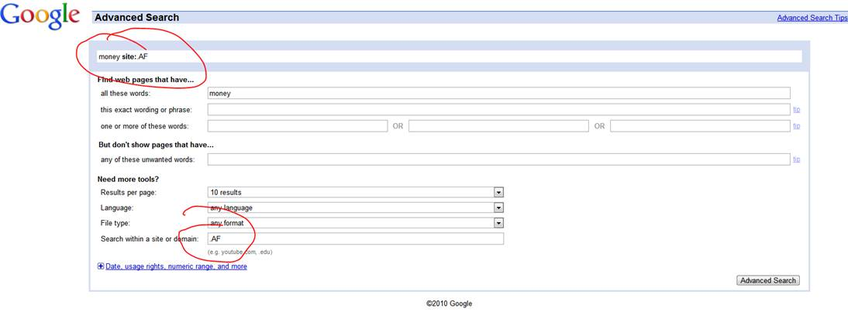

**Step 2:**  
Using your resources, put together a written project **in Spanish** with visual or auditory support (refer to our class website for links on how to type in accents in Spanish). The use of multimedia is encouraged (i.e. Powerpoint, Wiki, Glogster, Google Doc, Podcast, Videocast, Screencast, etc). Please let your teacher know if you need some assistance in this area.  
  
**Note:** Copying and pasting complete or partial sentences from other sources, without citing the author, is considered a copyright infringement. Please refer to our policy on [Academic Integrity](http://www.sd43.bc.ca/col/10-12/About/Policies/Policy%20Documents/Academic%20Integrity%20Policy.pdf). Images from the Internet can be used if you cite the link and/or owner of the image. Please ask for help if you are unsure. **I will be using software to determine the percentage of word phrases that are copied and pasted from the Internet. Please be very careful to not copy and paste.**  
  
**Step 3:**  
Post your work to the class site or wiki (location to be announced) for other students to view and respond to (or send to the teacher to be posted). Alternatively, you can present to the class in our virtual classroom.

*****Refer to the rubric on the next page to help guide you organizing your project.

**Assessment (20 marks)**

Exceeds                 Meets                    Barely Meets           Doesn’t meet

|  |  |  |  |  |
| --- | --- | --- | --- | --- |
| Depth & variety of both similarities and differences between Hispanic cultures.  **/4** | Points to specific examples to illustrate the similarities and differences. | Similarities and differences are mentioned but the supporting details are general and not specific. | Similarities and differences are mentioned but the supporting details are incomplete. Includes both comparison and contrast. | May include either similarities or differences and/or there are no supporting details or the support is incomplete. |
| Spanish Language: verb tense, variety of vocabulary and sentence structure, idiomatic expressions  **/4**. | Demonstrates a good understanding and control of appropriate verb tenses. Has varied sentence structure which integrates transitional words to link thoughts. May have errors which do not detract from meaning. Has a wide range of appropriate vocabulary and idioms which is predominantly correct | Demonstrates a reasonable  understanding and control of appropriate verb tenses. Has sentence structure which has some  variety and may integrate transitional words to link thoughts. Has errors which do not interfere with  the meaning. Has a good range of generally  appropriate vocabulary/  idioms which are mostly correct. | Has some understanding and control of appropriate verb tenses. Rarely goes beyond basic sentence  structure. May have errors which weaken the meaning. Rarely goes beyond high frequency vocabulary/idioms but is generally correct. | Has difficulty in controlling appropriate verb tenses. Demonstrates basic sentence structure. Has errors which interfere with the meaning. Has a limited range of  vocabulary/idioms which may be frequently incorrect. |
| Variety/ quality of resources and media  **/4** | A wide variety of resources is used in researching and producing the assignment - a wide diversity of perspectives is derived from them | A variety of resources is used in researching and producing the assignment - some diversity of perspectives is derived from them | Limited variety of resources is used in researching and producing the assignment - not much perspective is derived from them | Inadequate variety of resources is used in researching and producing the assignment - diversity of perspectives is not derived from them |
| Clarity of understanding  **/4** | Information is clear, relevant, accurate, and **detailed**. | Information is clear, relevant, and accurate. | Information is relevant and accurate, but may be unclear or inaccurate in places. | Attempts to address the topic but information may be unclear, incomplete, or inappropriate. May deal with requirements in a cursory way or show inconsistency. |
| Project Presentation  **/4** | Information is well-organized, and easy to understand.  The illustration(s), photo(s), sound or oral presentation is/are interesting, relevant, attractive, and supports the ideas described. | Information is displayed well. The illustration(s), photo(s), sound or oral presentation  supports the ideas described. | Information may seem to be displayed without purpose or relevance.  The illustration(s), photo(s), sound or oral presentation  is somewhat related to text. There is limited visual/auditory impact. | Some irrelevant information is included. Illustrations or photos may be missing, limited or unrelated to text. |